**Hack Challenge 2021  
  
AI-Assisted Farming For Crop Recommendation & Farm Yield Prediction Application**

**INTRODUCTION :**

***Overview***

Agriculture is one of the oldest activities of civilization. Traditional farming is carried out based on knowledge passed from ancestors and personal experiences. Currently, the food production is inadequate and doesn’t generate more income to farmers due to wrong crop cultivation according to farming factors like soil, climate, rainfall.

Purpose:

In this era of modern civilization and high population, the usage of machine learning tools will be useful for farmers and mankind.

**2. LITERATURE SURVEY**

***2.1 Existing Problem***

Farming is a profession, which involves dealing with life and nature. Nature as we know is very unpredictable. Thus, farmers are at the mercy of nature. The risk factor is very high as it might rain properly year, or it might be a drought or a flood. They can put in as much hard work as they can and still not reap the benefits of their hard work. Thus, their hard work can go to waste if nature decides otherwise.

Now, the population of the earth is 7.2 Billion. In a few decades, it is going to touch 10 Billion. In order to feed 10,000,000,000 people, farming has to modernize. Traditional methods is not going to cut it anymore where the crops grown in a land can be sub-optimal to those conditions. As the amount of fertility in the soil is limited, it has to be constantly monitored and maintained.

***2.2 Proposed Solution***

AI and IOT Solutions can be a game changer to the farming industry. These solutions can reduce the mental and physical workload farmers face, which can improve results with less effort and bring about better changes such as:

* Automate Crop harvesting and Plantation using ML Models which can give accurate timings for these tasks.
* Give Information on Revenue and Cost of Production for crops to farmers using the Dataset.
* Simplify Crop Selection for a particular land and find most profitable crop using ML Models.
* Real-Time Predictive Analysis is the next big thing in the IOT Sphere. Farmers can collect the data and determine the optimal use of fertilizers, irrigation and plantation systems. They can take action in real time with IOT Solutions.

Thus, the solution can help farmers minimize the risk in their profession and get the best results with minimal efforts. The idea can be split into 3 parts:

* Auto AI Model to give crop recommendation to farmers and give information on revenue
* IOT Device and Platform to give Real-Time Predictive Analysis

Django Web Application as a portal for farmers to access these Services.

**FLOWCHART**

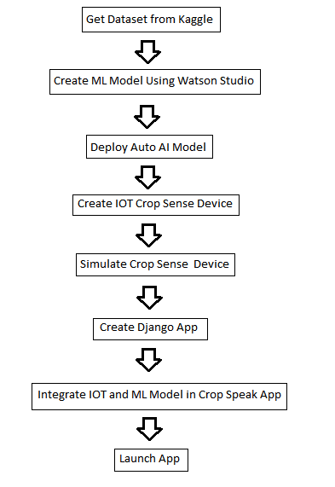

**RESULT**

***6.1 Results Achieved***

* Auto AI Model successfully built using the datasets with an accuracy of 99.1%.
* Django Application launched using Cloud Foundry Apps

IOT Platform Service integrated with Cloud and Website

**ADVANTAGES AND DISADVANTAGES**

***Advantages***

* Accurate Recommendations achieved using Watson Studio - 99.1%
* IOT Sensors give real time predictive analysis, which is displayed on the dashboard
* Interactive Website where users can input their sensor value data, if they do not have a crop sense sensor.
* The Website is free of cost to use.

***Disadvantages***

* Crop Sense Sensors require Internet services to be able to connect to the Cloud. This might not be available in remote regions of India
* Crop Sense Sensors are an added cost to the AI Assisted Solution, which might not be affordable by farmers who have smaller lands.

**APPLICATIONS**

* The Crop Speak and Crop Sense Systems can be used both in small scale and large scale farms. The Crop Sense IOT Device can be used even in gardens in the city. Irrigation Systems can be automated using the Crop Sense Device. Automatic Watering of plants is possible by combining Hardware and Software Solutions via the IBM IOT Platform.
* This App can help new comers in gardening or farming, helping them understand the planting and harvesting periods for crops.
* The modernization of farming can improve the society as a whole. Standing in the sun for hours in a day is no longer necessary if irrigation and and fertilizer systems are automated.
* Automated Farming can be an upcoming industry which can create new jobs and increase the GDP and productivity of the nation. Crops can be grown in surplus and exported to other countries if rapid modernization can be implemented to this industry.

**CONCLUSION**

To conclude, The Crop Speak and Crop Sense IOT Solutions is an integral part of automating the farming Industry. This solution can benefit the nation as a whole and the individual communities present in it. Being a cloud based solution, it can be implemented in a rapid scale and be integrated with multiple hardware solutions. Thus, the farming industry can be stepped upto industry 4.0 standards in the next coming years.